# 6. Understanding Social Structures of Family

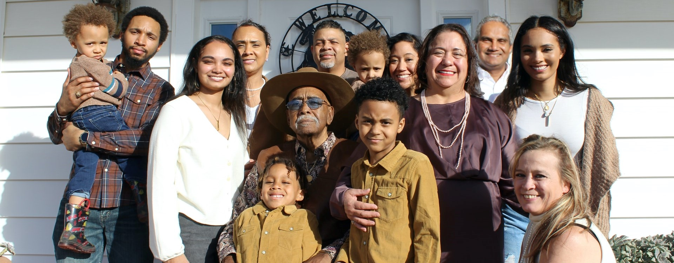

Picture of a big family with many generations together

Picture of a big family with many generations together

*Photo by Rajiv Perera from Unsplash*

## Overview

In Unit 4, we will study how societies around the world demonstrate remarkable variation in cultural understandings of family and marriage, and in how roles have certain rights and responsibilities, and provide status, privilege and power. Through readings and videos you will learn about different types of marriage: *who you can and may not marry, age for marriage, number of partners in marriage, and whether you even have a choice in choosing your marriage partner or in deciding where you will live or how many children you will have.*

### Topics

This unit is divided into the following topics:

1. Kinship and Descent
   * A Comparison of Kinship Terms in 4 Cultures: Croatia, China, Navajo, USA
2. Marriage and Family
   * A Comparison of 4 Types of Love: Papua New Guinea, Kenya, South India, Scotland

### Learning Outcomes

When you have completed this unit, you should be able to:

* Discuss the variation in rights and responsibilities and how these are associated with roles and status within a family and community.
* Identify the differences between kinship establish by blood and kinship established by marriage.
* Describe and illustrate the variety of human families cross-culturally; discern the different terms that define types of relationship.
* Distinguish between matrilineal, patrilineal, and bilateral kinship systems.
* Describe the variety of human families cross-culturally with examples.
* Evaluate the differences between dowry and bridewealth, as well as between different types of post-marital residence.
* Illustrate, with cultural examples, the types of relationship involving love and/or marriage.

### Activity Checklist

The content from these videos will be discussed during this unit’s Learning Lab so come prepared for a discussion.

## Learning Lab

* The Learning Lab in Unit 4 will begin with a group discussion on the subject matter from the videos in Topic 2. Be sure to preview the videos before arriving to the Learning Lab.
* Additionally, this Learning Lab will introduce the concept of Kinship Maps. Students will watch a video during the Learning Lab that explains how to create a Kinship Map and what the purpose of one is. This will serve as important background information before you begin your assignment for Unit 4. Your Facilitator will be leading the discussion - take some time to review the information found on the “Assessment” tab for Unit 4 before you arrive.

### Assessment

### Topic 1 Resources

* Brown, N., de González, L. T., McIlwraith, T. F., & American Anthropological Association. (2018). [*Perspectives: An Open Invitation to Cultural Anthropology.*](http://perspectives.americananthro.org/Chapters/Family_and_Marriage.pdf)
* Wesch, M. (2018). *The Art of Being Human: A Textbook for Cultural Anthropology.* New Prairie Press.
* Other online resources will be provided in the unit.

## 6.1 Kinship and Descent

Unit 4 begins by introducing the idea of kinship. In particular, we will explore an important question: *Who are the people you are related to by blood or through marriage?*

This topic covers terms and linkages for how to different ethnic groups identify and interact with their relatives.

This topic also follows Chapter 8 in your *Perspectives* textbook. In this chapter, you will be introduced to a lot of new terminology. You do not need to memorize every term in the chapter glossary, but you should be able to work with terminology and understand that the same term can mean different things in different cultures, (e.g. who is ‘mother’) and the same relationship can have different terms (e.g. a female marriage partner can be a first or third wife, or a widow or be re-married to her deceased husband’s brother).

We begin with a more in-depth study with the resources below….

### Resources

The resources below will help you better understand the content explored in this unit. Take some time to explore this material - it will be discussed during the Learning Lab and will play an important role in course assessments.

### Activity

## 6.2 Marriage and Family

We next shift our focus to exploring cultural norms about marriage and family. Below, this topic will be studied using several videos showing uncommon practices. Some ideologies and practices are unique to small and isolated people groups (*e.g. marriage among the Na people living in the foothills of the Himalayas* (Perspectives, 2020, p. 254)). Other perspectives, however, are not universal, but are global in that they are found in societies around the world - especially nowadays due to migration transferring traditional practices into modern cities (*e.g. female genital mutilation*). Some gender practices are harmful and have been addressed by advocacy groups. Examples of these include child marriage, dowry deaths, and honor killings. Many of these practices that you will learn about, are changing due to the influence of globalization, as members of their communities are exposed to contrasting outsider practices.

We begin with our resources below:

### Topic 2 Resources

The resources below will help you better understand the content explored in this unit. Take some time to explore this material - it will be discussed during the Learning Lab and will play an important role in course assessments.

We begin with resources that tell stories of how love and relationships are seen in societal structures around the world. Most of the practices you will watch and read about may not be practiced in your country or ethno-cultural group; however, they are still practiced to a greater or lesser extent, depending on country laws and changing cultural patterns. Many of these practices are changing due to global objections and the work of advocacy groups that fight for the basic Human Rights of dignity and equality of all persons.

The first video you are to watch is about child brides in India, Yemen, Afghanistan, Nepal and Ethiopia. Very often child brides are not the only wife, they may be the first or last wife in a polygamous marriage. The next video shows you what polygamy looks like in Togo, West Africa.

The article “Love in Four Cultures” illustrates how love is experienced in Papua New Guinea, in a Masai boarding school in Kenya, in a village in South India, and in Scotland. Sometimes, marriages are not built on love, but on family agreements that require a dowry or payment to either the bride’s family or groom’s family. Some dowry practices are harmful and may even be unethical or illegal, as you will see in the last video filmed in Bangladesh and India.

*With each of these practices, it is likely that there are stark differences to how your family expresses love, and observes marriage and family customs. Note that these practices need to be understood before they are criticized.* ***Your purpose here should be to understand the practice, and why and how it is practiced.***

### Activity Learning

## 6.3 Learning Lab

The Learning Lab for Unit 4 will focus on expanding our understanding of some of the themes and concepts from Topics 1 and 2 in this unit. Before you arrive to this unit’s Learning Lab, be sure to review the content from each section.

In addition to these discussions, the Facilitator will also be introducing the idea of ***kinship systems*** - this component of the Learning Lab will be integral for your **Kinship and Descent Mapping - Activity #2** assignment you will be submitting at the end of Unit 4.

To learn more about kinship systems, and to help prepare you for your assignment, watch the video below - as you watch, compare your own understanding of family relationships to what you are learning about here.

## 6.4 Assessment

The following criteria will be used to assess your submission:

Grade | % | Assessment Criteria |\

| :– | :- |  
 A+ | 4 | Above and beyond. Outstanding visual presentation and write-up. An A+ effort will involve several of the following: risk-taking, innovative thinking, resolving a difficult contradiction or paradox, and connecting or synthesizing ideas. |  
  A | 3.8 | Excellent work. Clear evidence that the core ideas of the topic or assignment have been understood and implemented. |  
  B | 3 | Good work, but there is not clear evidence that the core ideas of the topic or assignment have been understood, or the work could be improved through better writing, more writing, or better visuals. |  
 C+ | 2.2 | Fair work. Work is complete but it appears rushed and unpolished, or there is no evidence of understanding and some evidence of misunderstanding. |  
  D | 1 | Poor work. Work was submitted but it is incomplete, incorrect, or off the mark. |  
  F | 0 | Very poor work. Something was submitted but it is minimal, incomplete, wrong, or off the mark. |

Once you have completed your diagram, submit it for grading by selecting the **Kinship and Descent Mapping - Activity #2** assignment dropbox at the bottom of the page.

*This activity will represent 4% of your overall grade for the course - this submission will be graded by your Facilitator.*